Practical-1: Intermediate Programs Using User-Deƒined Function

1) | Return the maximum of three floating-point numbers. (A)
Program :-
#include <stdio.h>
float maxOfThree(float ,float ,float);
void main(){
float n1,n2,n3;
printf("Enter the first Number : ");
scanf("%f",&n1);
printf("Enter the second Number : ");
scanf("%f",&n2);
printf("Enter the third Number : ");
scanf("%f",&n3);
float max = maxOfThree(n1,n2,n3);
printf("Max = %.2f",max); //up to two decimal point round of
}
float maxOfThree(float n1,float n2,float n3){
if(n1 > n2){
if(n1 > n3){
return n1;
}
else{
return n3;
}
}
else{
if(n2 > n3){
return n2;
}
else{
return n3;
}
}
}

 | Output :-
 | 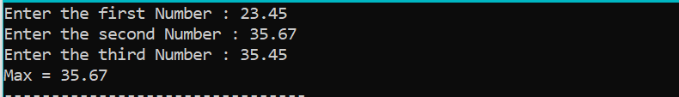
2) | Return the minimum of three floating-point numbers.?(A)
 | Program :-
#include <stdio.h>
float minOfThree(float ,float ,float);
void main(){
float n1,n2,n3;
printf("Enter the first Number : ");
scanf("%f",&n1);
printf("Enter the second Number : ");
scanf("%f",&n2);
printf("Enter the third Number : ");
scanf("%f",&n3);
float max = minOfThree(n1,n2,n3);
printf("Min = %.2f",max); //up to two decimal point round of
}
float minOfThree(float n1,float n2,float n3){
if(n1 < n2){
if(n1 < n3){
return n1;
}
else{
return n3;
}
}
else{
if(n2 < n3){
return n2;
}
else{
return n3;
}
}
}
 | Output :-
 | 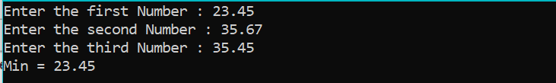
3) | Swap two numbers using call by value and call by reference.?(A)
 | Program :-
#include <stdio.h>
void swapByCallByValue(int, int);
void swapByCallByReference(int*, int*);
void main(){
int n1,n2;
printf("Enter the n1 : ");
scanf("%d",&n1);
printf("Enter the n2 : ");
scanf("%d",&n2);
//call by value
//can not change in Actual Parameter
swapByCallByValue(n1,n2);
//call by reference
//also change in Actual Parameter
swapByCallByReference(&n1,&n2);
printf("call by reference \n");
printf("n1 = %d and n2 = %d \n",n1,n2);
}

void swapByCallByValue(int n1, int n2){
//formal Parameter
int temp = n1;
n1 = n2;
n2 = temp;
printf("call by value \n");
printf("n1 = %d and n2 = %d \n",n1,n2);
}

void swapByCallByReference(int* p1, int* p2){
int temp = *p1;
*p1 = *p2;
*p2 = temp;
}
 | Output :-
 | 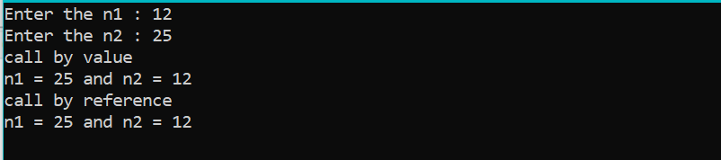
4) | Find all prime numbers between given interval using functions.?(B)
 | Program :-
#include<stdio.h>
void findPrime(int ,int);
int isPrime(int);
void main(){
int start,end;
printf("Enter the start : ");
scanf("%d",&start);
printf("Enter the end : ");
scanf("%d",&end);
findPrime(start,end);
}
void findPrime(int start,int end){
int i = 0;
for(i=start;i<=end;i++){
if(isPrime(i)==1){
printf("%d \n",i);
}
else{
continue;
}
}
}
int isPrime(int n){
int count = 0;
int i = 0;
for(i=1;i<=n;i++){
if(n%i==0){
count++;
}
}
if(count == 2){
return 1;
}
else{
return 0;
}
}
 | Output :-
 | 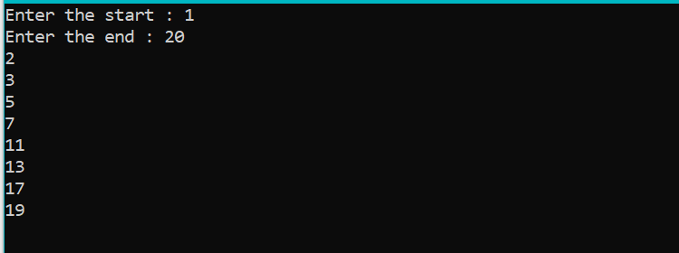
5) | Create a function that converts amount into words.  (i.e. 9241: Nine Thousand Two Hundred Forty One)?(C)
 | Program :-
#include <stdio.h>
#include <string.h>

void number_to_words(int);

void main() {
int n = 0;
printf("Enter the Four Digit Number : ");
scanf("%d",&n);
number_to_words(n);
}

void number_to_words(int n) {
char result[1024] = "";
// Arrays for number words
char *ones[] = { "", "One", "Two", "Three", "Four", "Five", "Six", "Seven", "Eight", "Nine", "Ten"};
char *teens[] = {"Ten","Eleven", "Twelve", "Thirteen", "Fourteen", "Fifteen", "Sixteen", "Seventeen", "Eighteen", "Nineteen" };
char *tens[] = { "", "", "Twenty ", "Thirty ", "Forty ", "Fifty ", "Sixty ", "Seventy ", "Eighty ", "Ninety " };

if (n == 0) {
printf("Zero");
return;
}
if(n >= 1000){
strcat(result,ones[n/1000]);
strcat(result," Thousand ");
n = n % 1000;
}
if(n >= 100){
strcat(result,ones[n/100]);
strcat(result," Hundred ");
n = n % 100;
}
if(n >= 20){
strcat(result,tens[n/10]);
n = n % 10;
strcat(result,ones[n]);
n = 0;
}
if(n >= 10){
strcat(result,teens[n%10]);
n = 0;
}
if(n > 0){
strcat(result,ones[n]);
n = 0;
}
puts(result);
}

 | Output :-
 | 